**Proiect SCIA**

# Tematica proiectului

Specificatii generale:

ETAJ 1:

Sursa semnal:4(current diferential)

Amplitudine minima(pt castig maxim PGA):2.00e-05

Amplitudine maxima(pt castig minim PGA):5.02e-05

Unitate masura(A diferential)

Tip etaj1:6(AI cu 2AO;Inversor,intrare I)

|Castig| etaj 1(liniar):10K

ETAJ 2:

Tip etaj 2:9(Trece banda;1 AO V-V, Delyiannis)

|H0|castig liniar in banda de trecere:1

Rintrare minim:2kΩ

Banda:5khz

Q=1.41

ETAJ 3:

Tip etaj 3:5(RF serie)

Castig minim[dB]:2

Rezolutie(pas minim[dB]):2

Nr. pasi:5

Castig maxim[dB]:20

Rintrare minim:-

ETAJ 4:

Tip etaj:6(redresor dubla alternanta FWR v6)

Castig(liniar):2

TIP AO:4(LT6234;+/-5V)

# Dimensionarea etajului 1 / 2 / 3 / 4

**ETAJUL 1:**

* Daca

=>

,

= (castigul) => $R_{4}=10kΩ$

Aleg $R_{2}$ = $R_{3}$ =10k $Ω$

Aleg $I_{A}=0.5A$

$I_{B}$ =-0.5A

Amplitudine maxima(pt castig PGA maxim):5,02*e-05(A diferential)

Amplitudine minima(pt castig PGA minim):2*e-05(A diferential)

* Offset=(5,02*e-05+2*e-05)/2=3.51*e-05=35.1uA
* Amplitudinea(Av)=5,02*3e-05-3,51*e-05=15.1uA

**ETAJUL 2:**

Parametrii functiei de transfer:



Aleg:



(castig liniar in banda de trecere)

$$R_{in_{minim}}=2k,$$

$$B_{-3dB}=5khz$$

Q=1.41

Fie k=0.16 si r=16

R=20kΩ

$$R_{2}=r*R=16*20=320kΩ$$

$$f_{0}=5khz$$

$$2*π*5*{10}^{3}=\frac{1}{RC}*\sqrt{\frac{k}{r}}=>π*{10}^{4}=\frac{1}{20k*C}*\sqrt{\frac{0.16}{16}}=\frac{0.1}{20k*C}=>$$

$$C=\frac{1}{20k*π*{10}^{4}*10}={10}^{-9}*\frac{1}{2*π}≅0.16nF$$

$$C_{1}=C=0.16nF$$

$$C_{2}=\frac{C}{k}=\frac{0.16nF}{0.16}=1nF$$

$$H_{0}=\frac{R_{2}}{R_{1}}*\frac{1}{1+k}$$

$R_{1}=\frac{R_{2}}{k+1}=\frac{320k}{1.16}$ =275.86kΩ

$$R_{3}=\frac{R_{1}*R}{R_{1}-R}=\frac{275.86k*20k}{255.86k}=21.56kΩ$$

**ETAJUL 3:**

=>

AO neinversor=> $A_{V}$ =(1+ $\frac{R_{ech}}{R_{G}})$

**Sw1=on(castig minim): $A_{V}=4$**

$R_{ech}=R_{F1}$, $A_{V}$ =(1+ $\frac{R_{ech}}{R_{G}})$ => $R_{F1}=(A_{V}-1)R_{G}$

Aleg $R_{G}=100Ω$

$$R_{F1}=\left(4-1\right)*R_{G}=3*100Ω=300Ω$$

**Sw2=on: $A_{V}=5$**

$$R_{ech}=R_{F1}+R_{F2}$$

$$R_{F1}+R_{F2}=\left(5-1\right)R_{G}=4R_{G}$$

$$R_{F2}=4R_{G}-R_{F1}=$$

$$=400-300=$$

$$=100Ω$$

**Sw3=on: $A_{V}=6.3$**

$$R_{ech}=R_{F1}+R_{F2}+R_{F3}$$

$R_{F1}+R_{F2}+R_{F3}$ =5 ${.3R}_{G}$

$R_{F3}$ =5 $R_{G}-R_{F2}-R_{F1}$ =

=530-100-300=

=130Ω

**Sw4=on: $A_{V}=8$**

$$R_{ech}=R_{F1}+R_{F2}+R_{F3}+R_{F4}$$

$$R_{F1}+R_{F2}+R_{F3}+R_{F4}=7R_{G}$$

$R_{F4}=8R_{G}-R_{F1}-R_{F2}-R_{F3}-R_{F4}$ =

=700-300-100-130=

=170Ω

**Sw5=on: $A_{V}=10$**

$$R_{ech}=R_{F1}+R_{F2}+R_{F3}+R_{F4}+R_{F5}$$

$R_{F1}+R_{F2}+R_{F3}+R_{F4}+R_{F5}$ =9 $R_{G}$

$R_{F5}=9R_{G}-R_{F1}-R_{F2}-R_{F3}-R_{F4}$ =

=900-300-100-130-170=

=200Ω

**ETAJUL 4:**

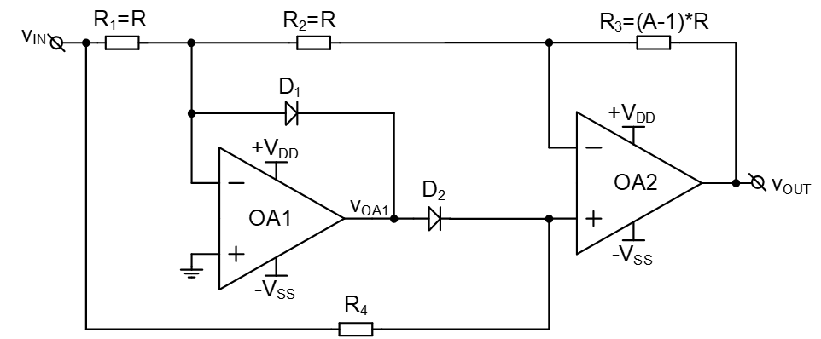

Presupunem D1,D2=OFF

$V_{IN}=-V_{SS}$

Pentru AO1:

=

OA1 in bucla de reactie negative deoarece ${V_{2}}^{+}={V_{2}}^{-} => {V_{1}}^{+}={V_{1}}^{-}=0$

$$=> I_{R1}=\frac{V_{IN}}{R_{1}}$$

$$I_{R1}=I_{R2}=I_{R3}=\frac{V_{IN}}{R_{1}}$$

$$V_{OUT}=0-I_{R1}\left(R_{2}+R_{3}\right)$$

$$V_{OUT}=-\frac{V_{IN}}{R_{1}}\left(R_{2}+R_{3}\right)=-(\frac{R_{2}+R_{3}}{R_{1}})V_{IN}$$

$V_{IN}=V_{DD}$

Pentru AO1:

$${V^{+}=0 \atop V^{-}=V_{DD}}\}=> V_{OA1}↘{-V}_{SS}$$

$V_{OA}=a_{∞}(V^{+}-V^{-})$ = $∞\left(0-V_{DD}\right)<0=>V_{OA1}↘-V_{SS}$

$$V_{AK1}=V_{DD}-\left(-V_{SS}\right)>0 => D1=ON$$

$$V_{AK2}=-V_{SS}-V_{DD}<0 => D2=OFF$$

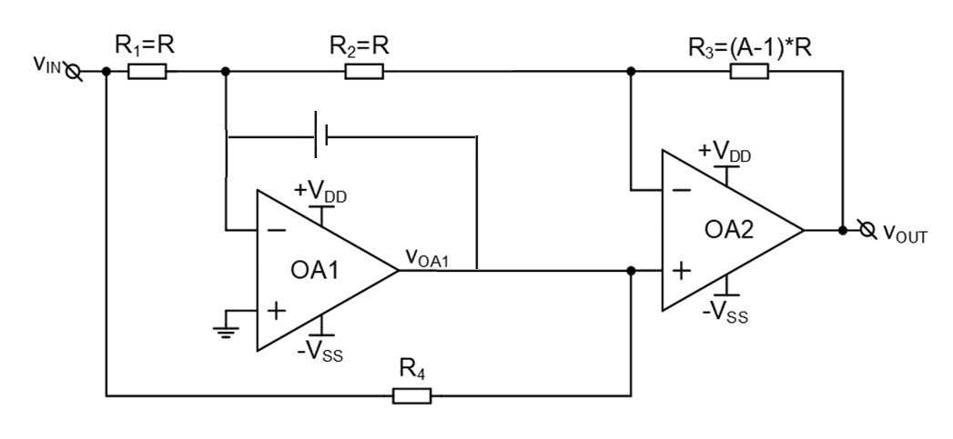

Exista Reactie Negativa prin D1:

${V_{1}}^{+}={V_{1}}^{-}$ =>AO2 neinversor

$$V_{OUT}=(1+\frac{R_{3}}{R_{2}})V_{IN}$$

CONDITIA REDRESOR BIALTERNANTA: $R_{1}=R_{2}$

Concluzie:

⬄

=> A=

||=2(liniar)

||==

Aleg $R_{1}$ = $R_{3}$ = $R_{3}$ = $R_{4}$ =10kΩ



# Caracterizarea etajului 1 / 2 / 3 / 4. Verificarea si caracterizarea interfetei analogice

**Etajul 1:**

* Parametrii DCOP :
* **Starting Gmin stepping**
* **Gmin = 10**
* **Gmin = 1.07374**
* **Gmin = 0.115292**
* **Gmin = 0.0123794**
* **Gmin = 0.00132923**
* **Gmin = 0.000142725**
* **Gmin = 1.5325e-05**
* **Gmin = 1.6455e-06**
* **Gmin = 1.76685e-07**
* **Gmin = 1.89714e-08**
* **vernier = 0.5**
* **vernier = 0.25**
* **vernier = 0.125**
* **Gmin = 1.49241e-08**
* **vernier = 0.166667**
* **vernier = 0.222222**
* **Gmin = 1.00912e-08**
* **vernier = 0.296296**
* **Gmin = 5.38725e-09**
* **vernier = 0.395061**
* **vernier = 0.526748**
* **Gmin = 1.96664e-09**
* **vernier = 0.702331**
* **vernier = 0.936441**
* **Gmin = 4.16555e-10**
* **vernier = 1**
* **Gmin = 4.76818e-11**
* **Gmin = 5.11979e-12**
* **Gmin = 5.49733e-13**
* **Gmin = 0**
* **Gmin stepping succeeded in finding the operating point.**
* **N-Period=1**
* **Fourier components of V(out)**
* **DC component:0.350998**
* **Harmonic Frequency Fourier Normalized Phase Normalized**
* **Number [Hz] Component Component [degree] Phase [deg]**
* **1 1.000e+3 1.510e-1 1.000e+0 90.00° 0.00°**

**2 2.000e+3 1.839e-9 1.218e-8 16.92° -73.08°**

**3 3.000e+3 1.934e-9 1.281e-8 24.55° -65.46°**

**4 4.000e+3 2.062e-9 1.366e-8 31.27° -58.73°**

**5 5.000e+3 2.216e-9 1.468e-8 37.12° -52.88°**

**6 6.000e+3 2.391e-9 1.584e-8 42.15° -47.86°**

**7 7.000e+3 2.582e-9 1.711e-8 46.44° -43.57°**

**8 8.000e+3 2.786e-9 1.845e-8 50.10° -39.91°**

**9 9.000e+3 2.999e-9 1.987e-8 53.22° -36.78°**

**10 1.000e+4 3.221e-9 2.134e-8 55.91° -34.09°**

**Partial Harmonic Distortion: 0.000005%**

**Total Harmonic Distortion: 0.000000%**

**Date: Wed Jan 17 21:40:28 2024**

**Total elapsed time: 0.233 seconds.**

**tnom = 27**

**temp = 27**

**method = modified trap**

**totiter = 2984**

**traniter = 2120**

**tranpoints = 1061**

**accept = 1058**

**rejected = 3**

**matrix size = 25**

**fillins = 31**

**solver = Normal**

**Avg thread counts: 2.9/4.8/4.8/2.9**

**Matrix Compiler1: 2.90 KB object code size 2.6/1.6/[1.0]**

**Matrix Compiler2: 3.01 KB object code size 0.6/0.7/[0.3]**

* Parametrii semnal mic:

Castig:10kV(liniar)

Banda la -3dB:1.85Mhz

CMRR(factorul de rejectie al modului comun):114.92dB

* Parametrii semnal mare:

SR:28.64V/us

**Etajul 2:**

* Parametrii DCOP:
* **Circuit: * C:\Users\danci\OneDrive\Desktop\Proiect_SCIA\etajul2\etajul 2.asc**
* **Direct Newton iteration failed to find .op point. (Use ".option noopiter" to skip.)**
* **Starting Gmin stepping**
* **Gmin = 10**
* **Gmin = 1.07374**
* **Gmin = 0.115292**
* **Gmin = 0.0123794**
* **Gmin = 0.00132923**
* **Gmin = 0.000142725**
* **Gmin = 1.5325e-05**
* **Gmin = 1.6455e-06**
* **Gmin = 1.76685e-07**
* **Gmin = 1.89714e-08**
* **vernier = 0.5**
* **vernier = 0.25**
* **vernier = 0.125**
* **Gmin = 1.49241e-08**
* **vernier = 0.166667**
* **vernier = 0.222222**
* **Gmin = 1.00912e-08**
* **vernier = 0.296296**
* **Gmin = 5.38725e-09**
* **vernier = 0.395061**
* **vernier = 0.526748**
* **Gmin = 1.96664e-09**
* **vernier = 0.702331**
* **vernier = 0.936441**
* **Gmin = 4.16555e-10**
* **vernier = 1**
* **Gmin = 4.76818e-11**
* **Gmin = 5.11979e-12**
* **Gmin = 5.49733e-13**
* **Gmin = 0**
* **Gmin stepping succeeded in finding the operating point.**
* **N-Period=1**
* **Fourier components of V(out_tb)**
* **DC component:0.480015**
* **Harmonic Frequency Fourier Normalized Phase Normalized**
* **Number [Hz] Component Component [degree] Phase [deg]**
* **1 1.000e+3 1.501e-1 1.000e+0 -171.35° 0.00°**
* **2 2.000e+3 2.371e-7 1.579e-6 178.46° 349.81°**
* **3 3.000e+3 2.361e-7 1.573e-6 177.69° 349.04°**
* **4 4.000e+3 2.346e-7 1.563e-6 176.92° 348.27°**
* **5 5.000e+3 2.328e-7 1.550e-6 176.14° 347.49°**
* **6 6.000e+3 2.305e-7 1.535e-6 175.36° 346.71°**
* **7 7.000e+3 2.278e-7 1.517e-6 174.57° 345.92°**
* **8 8.000e+3 2.247e-7 1.496e-6 173.78° 345.13°**
* **9 9.000e+3 2.211e-7 1.473e-6 172.98° 344.32°**
* **10 1.000e+4 2.172e-7 1.447e-6 172.16° 343.51°**
* **Partial Harmonic Distortion: 0.000458%**
* **Total Harmonic Distortion: 0.006198%**
* **Date: Wed Jan 17 22:31:34 2024**
* **Total elapsed time: 0.273 seconds.**
* **tnom = 27**
* **temp = 27**
* **method = modified trap**
* **totiter = 2942**
* **traniter = 2092**
* **tranpoints = 1047**
* **accept = 1046**
* **rejected = 1**
* **matrix size = 16**
* **fillins = 11**
* **solver = Normal**
* **Avg thread counts: 2.9/4.8/4.8/2.9**
* **Matrix Compiler1: 1.21 KB object code size 1.4/0.7/[0.7]**
* **Matrix Compiler2: 1.66 KB object code size 0.5/0.6/[0.3]**

Parametrii semnal mic:

|H0|(Castig liniar in banda de trecere):1

Banda:5kHz

(THD<1%)

**ETAJUL 3:**

* Parametrii DCOP (pentru primul switch=on; castig minim)
* **Circuit: * C:\Users\danci\OneDrive\Desktop\Proiect_SCIA\etajul3\etajul 3.asc**
* **Direct Newton iteration failed to find .op point. (Use ".option noopiter" to skip.)**
* **Starting Gmin stepping**
* **Gmin = 10**
* **Gmin = 1.07374**
* **Gmin = 0.115292**
* **Gmin = 0.0123794**
* **Gmin = 0.00132923**
* **Gmin = 0.000142725**
* **Gmin = 1.5325e-05**
* **Gmin = 1.6455e-06**
* **Gmin = 1.76685e-07**
* **Gmin = 1.89714e-08**
* **Gmin = 2.03704e-09**
* **Gmin = 2.18725e-10**
* **Gmin = 2.34854e-11**
* **Gmin = 2.52173e-12**
* **Gmin = 2.70769e-13**
* **Gmin = 0**
* **Gmin stepping succeeded in finding the operating point.**
* **N-Period=1**
* **Fourier components of V(out)**
* **DC component:0.00045156**
* **Harmonic Frequency Fourier Normalized Phase Normalized**
* **Number [Hz] Component Component [degree] Phase [deg]**
* **1 1.000e+3 8.001e-1 1.000e+0 90.00° 0.00°**
* **2 2.000e+3 2.638e-6 3.297e-6 179.70° 89.70°**
* **3 3.000e+3 3.961e-7 4.951e-7 97.39° 7.39°**
* **4 4.000e+3 1.296e-7 1.620e-7 167.54° 77.55°**
* **5 5.000e+3 1.340e-7 1.675e-7 177.22° 87.22°**
* **6 6.000e+3 1.292e-7 1.615e-7 161.32° 71.32°**
* **7 7.000e+3 1.285e-7 1.607e-7 156.89° 66.89°**
* **8 8.000e+3 1.279e-7 1.598e-7 154.83° 64.83°**
* **9 9.000e+3 1.271e-7 1.588e-7 151.65° 61.65°**
* **10 1.000e+4 1.263e-7 1.578e-7 148.13° 58.13°**
* **Partial Harmonic Distortion: 0.000336%**
* **Total Harmonic Distortion: 0.013323%**
* **Date: Wed Jan 17 22:55:54 2024**
* **Total elapsed time: 0.503 seconds.**
* **tnom = 27**
* **temp = 27**
* **method = modified trap**
* **totiter = 2608**
* **traniter = 2116**
* **tranpoints = 1059**
* **accept = 1055**
* **rejected = 4**
* **matrix size = 60**
* **fillins = 45**
* **solver = Normal**
* **Avg thread counts: 2.9/4.8/4.8/2.9**
* **Matrix Compiler1: 5.67 KB object code size 3.3/1.8/[1.0]**
* **Matrix Compiler2: 6.42 KB object code size 1.6/1.7/[0.9]**
* Parametrii DCOP (pentru ultimul switch=on; castig maxim)
* **Circuit: * C:\Users\danci\OneDrive\Desktop\Proiect_SCIA\etajul3\etajul 3.asc**
* **Direct Newton iteration failed to find .op point. (Use ".option noopiter" to skip.)**
* **Starting Gmin stepping**
* **Gmin = 10**
* **Gmin = 1.07374**
* **Gmin = 0.115292**
* **Gmin = 0.0123794**
* **Gmin = 0.00132923**
* **Gmin = 0.000142725**
* **Gmin = 1.5325e-05**
* **Gmin = 1.6455e-06**
* **Gmin = 1.76685e-07**
* **Gmin = 1.89714e-08**
* **Gmin = 2.03704e-09**
* **Gmin = 2.18725e-10**
* **Gmin = 2.34854e-11**
* **Gmin = 2.52173e-12**
* **Gmin = 2.70769e-13**
* **Gmin = 0**
* **Gmin stepping succeeded in finding the operating point.**
* **N-Period=1**
* **Fourier components of V(out)**
* **DC component:0.00134897**
* **Harmonic Frequency Fourier Normalized Phase Normalized**
* **Number [Hz] Component Component [degree] Phase [deg]**
* **1 1.000e+3 1.999e+0 1.000e+0 90.00° 0.00°**
* **2 2.000e+3 2.536e-6 1.269e-6 179.45° 89.45°**
* **3 3.000e+3 1.056e-6 5.286e-7 81.09° -8.92°**
* **4 4.000e+3 5.972e-8 2.988e-8 121.61° 31.60°**
* **5 5.000e+3 5.407e-8 2.705e-8 -172.42° -262.42°**
* **6 6.000e+3 8.227e-8 4.117e-8 112.75° 22.75°**
* **7 7.000e+3 9.912e-8 4.960e-8 107.20° 17.20°**
* **8 8.000e+3 1.060e-7 5.302e-8 107.71° 17.71°**
* **9 9.000e+3 1.174e-7 5.874e-8 106.22° 16.22°**
* **10 1.000e+4 1.299e-7 6.499e-8 104.55° 14.55°**
* **Partial Harmonic Distortion: 0.000138%**
* **Total Harmonic Distortion: 0.011595%**
* **Date: Wed Jan 17 22:57:40 2024**
* **Total elapsed time: 0.388 seconds.**
* **tnom = 27**
* **temp = 27**
* **method = modified trap**
* **totiter = 2631**
* **traniter = 2148**
* **tranpoints = 1075**
* **accept = 1065**
* **rejected = 10**
* **matrix size = 60**
* **fillins = 45**
* **solver = Normal**
* **Avg thread counts: 2.9/4.7/4.7/2.9**
* **Matrix Compiler1: 5.67 KB object code size 2.9/1.5/[1.0]**
* **Matrix Compiler2: 6.42 KB object code size 1.5/1.5/[0.9]**

Parametrii semnal mic:

Castig minim(12dB):

Banda la -3dB:14.33MHz:

Castig 14dB si banda la -3dB=12.29MHz:

Castig 16dB si banda la -3dB=10.61MHz:

Castig 18dB si banda la -3dB=9.065MHz:

Castig 20dB si banda la -3dB=7.65MHz:

Etajul 4:

Parametrii DCOP:

**Circuit: * C:\Users\danci\OneDrive\Desktop\Proiect_SCIA\etajul4\etajul 4.asc**

**Direct Newton iteration failed to find .op point. (Use ".option noopiter" to skip.)**

**Starting Gmin stepping**

**Gmin = 10**

**Gmin = 1.07374**

**Gmin = 0.115292**

**Gmin = 0.0123794**

**Gmin = 0.00132923**

**Gmin = 0.000142725**

**Gmin = 1.5325e-05**

**Gmin = 1.6455e-06**

**Gmin = 1.76685e-07**

**Gmin = 1.89714e-08**

**vernier = 0.5**

**vernier = 0.25**

**vernier = 0.125**

**vernier = 0.0625**

**vernier = 0.03125**

**vernier = 0.015625**

**vernier = 0.0078125**

**vernier = 0.00390625**

**vernier = 0.00195312**

**Gmin = 1.89714e-08**

**vernier = 0.000976562**

**vernier = 0.000488281**

**Gmin = 0**

**Gmin stepping failed**

**Starting source stepping with srcstepmethod=0**

**Source Step = 3.0303%**

**Source Step = 24.4318%**

**vernier = 0.015625**

**Source Step = 24.2661%**

**Starting source stepping with srcstepmethod=1**

**Source Step = 3.0303%**

**Source Step = 33.3333%**

**Source Step = 63.6364%**

**Source Step = 93.9394%**

**Source Step = 100%**

**Source Step = 99.1894%**

**Source Step = 99.6629%**

**Source Step = 99.9973%**

**Source Step = 100%**

**Source stepping failed**

**Pseudo Transient succeeded in finding the operating point at 325.549 ms.**

**N-Period=1**

**Fourier components of V(out)**

**DC component:0.0180656**

**Harmonic Frequency Fourier Normalized Phase Normalized**

**Number [Hz] Component Component [degree] Phase [deg]**

**1 1.000e+3 1.994e+0 1.000e+0 -89.96° 0.00°**

**2 2.000e+3 5.724e-3 2.871e-3 -179.91° -89.95°**

**3 3.000e+3 5.250e-3 2.633e-3 -89.87° 0.10°**

**4 4.000e+3 4.646e-3 2.330e-3 0.18° 90.14°**

**5 5.000e+3 3.962e-3 1.987e-3 90.22° 180.18°**

**6 6.000e+3 3.249e-3 1.629e-3 -179.73° -89.77°**

**7 7.000e+3 2.554e-3 1.281e-3 -89.69° 0.27°**

**8 8.000e+3 1.917e-3 9.614e-4 0.35° 90.31°**

**9 9.000e+3 1.363e-3 6.838e-4 90.39° 180.36°**

**10 1.000e+4 9.087e-4 4.558e-4 -179.56° -89.60°**

**Partial Harmonic Distortion: 0.551785%**

**Total Harmonic Distortion: 0.552760%**

**Date: Thu Jan 18 00:06:08 2024**

**Total elapsed time: 0.951 seconds.**

**tnom = 27**

**temp = 27**

**method = modified trap**

**totiter = 14970**

**traniter = 2254**

**tranpoints = 1128**

**accept = 1103**

**rejected = 35**

**matrix size = 24**

**fillins = 62**

**solver = Normal**

**Avg thread counts: 2.8/4.6/4.6/2.8**

**Matrix Compiler1: 4.77 KB object code size 1.2/0.6/[0.6]**

**Matrix Compiler2: 3.68 KB object code size 1.0/1.0/[0.5]**

Castigul liniar:2

Implementare functie de circuit(cu AO: AD820 SI LT6234)

Implementare functie de circuit(doar cu AO LT6234)

# Concluzii

Compararea rezultatelor obtinute cu cerintele impuse:

Cerinte impuse:



Rezultate obtinute:

Etaj 1:

Castig(liniar):9.99Kv

Banda etaj1:1.85MHz

Etaj 2:

Castig (liniar) in banda de trecere: 998.44mV

Banda:4.966kHz

Etajul 3:

Castig=12dB(cerinte):12dB masurat

Banda:14.33MHz

Castig=14dB(cerinte):14dB masurat

Banda: 12.29MHz:

Castig=16dB(cerinte):15.99dB masurat

Banda:10.61MHz:

Castig=18dB(cerinte):18.06dB masurat

Banda:9.065MHz

Castig=20dB(cerinte):20dB masurat

Banda:7.65MHz

Etaj 4:

Castig liniar=2(cerinte):2 masurat

Schema Bloc

